ME EN 2450 Final Project Discussion

Barrett Carpenter, u1421693

Kevin Duprey, u1406068

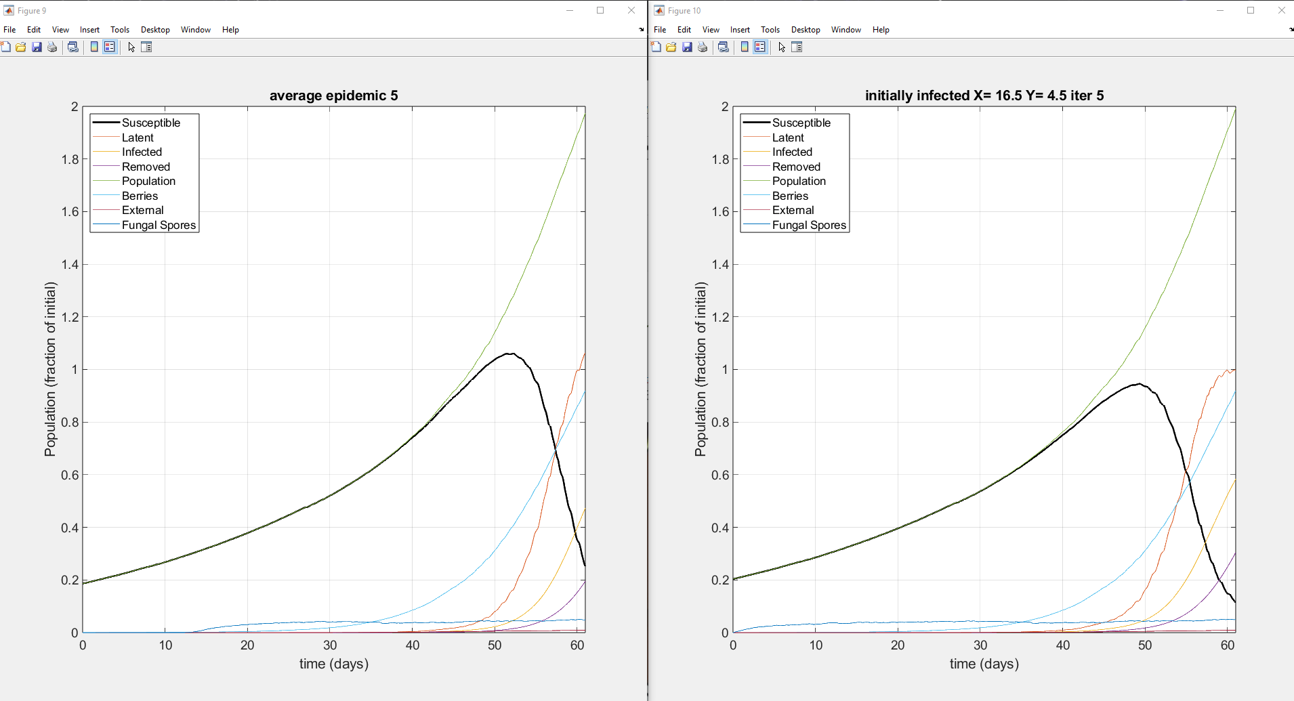

Figure of the average pandemic (right) and of the initially infected plant population for the fifth iteration.

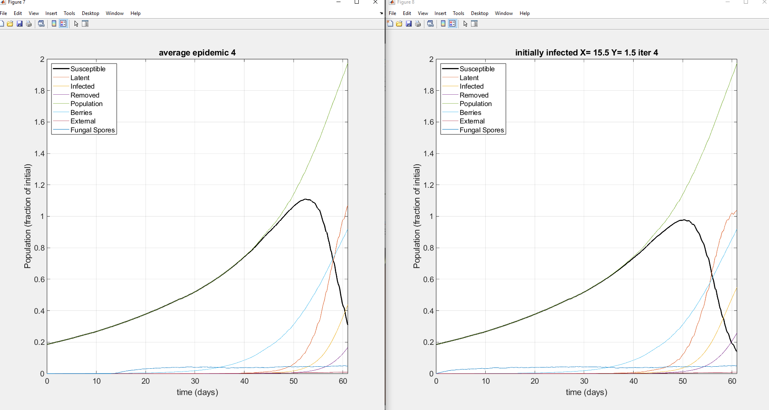

Figure of the average pandemic (right) and of the initially infected plant population for the fourth iteration.

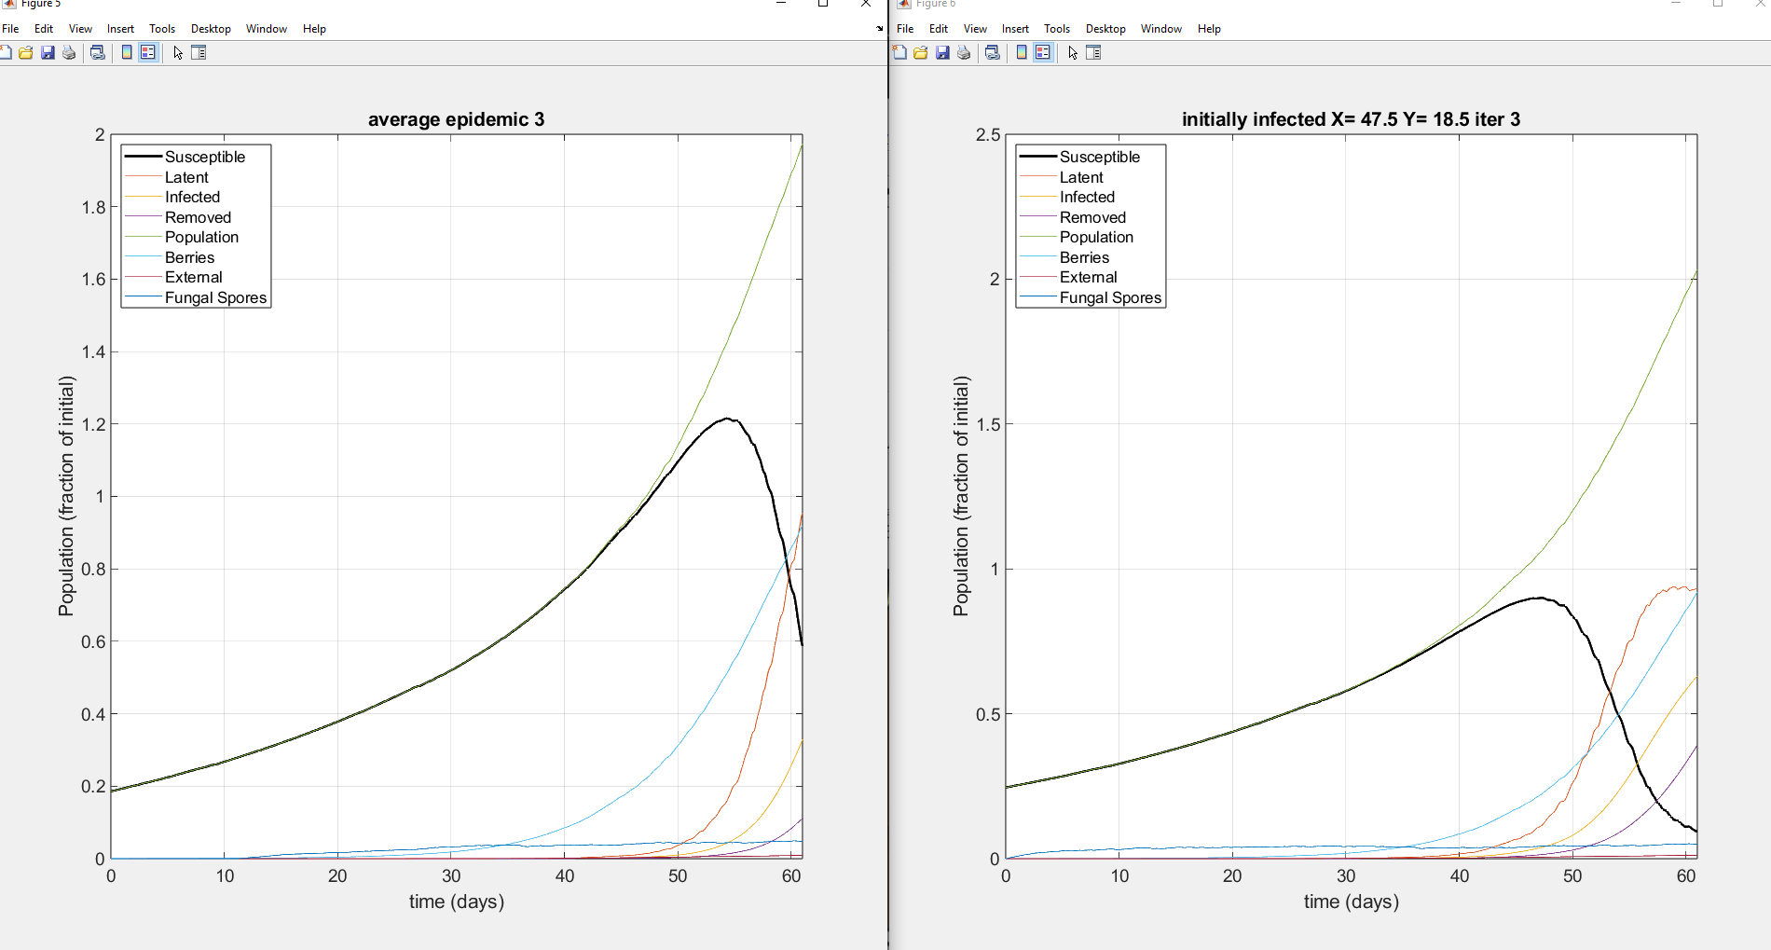

Figure of the average pandemic (right) and of the initially infected plant population for the third iteration.

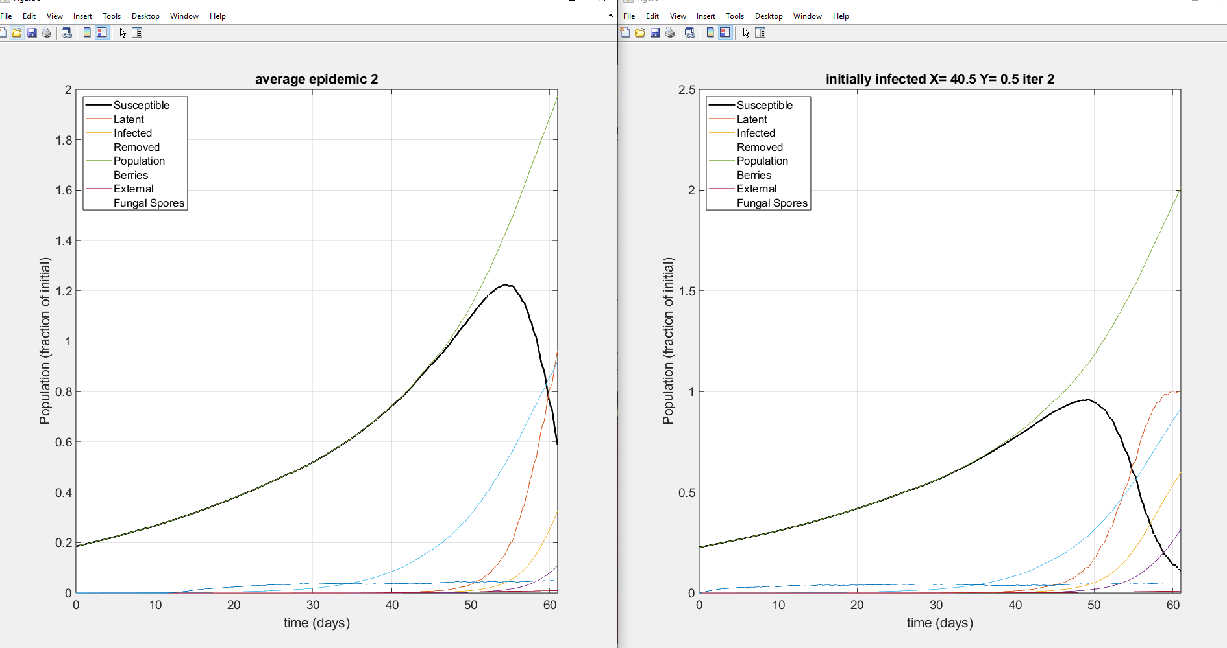

Figure of the average pandemic (right) and of the initially infected plant population for the second iteration.

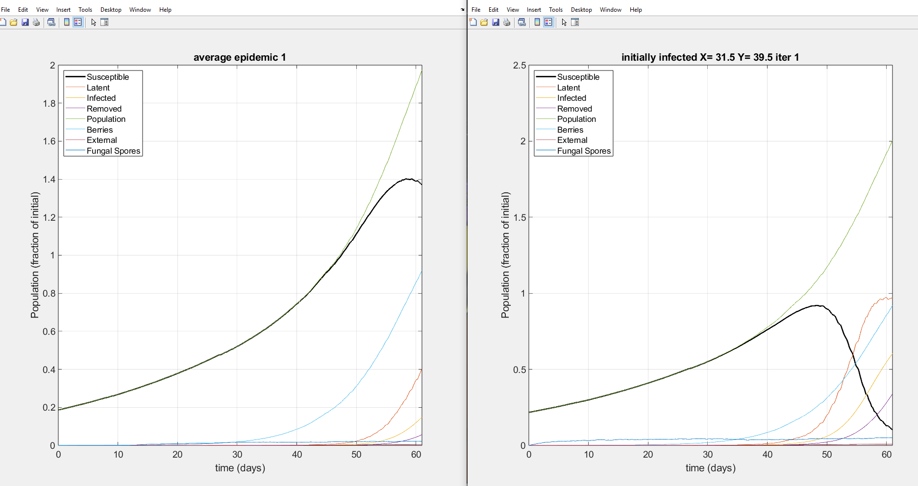

Figure of the average pandemic (right) and of the initially infected plant population for the first iteration.

The model created and shown above represents the spread of a fungal infection across a given field of plants (In this case a field of 2500 plants (50x50)). The infection spreads through fungal spores released from the host plant’s leaves by the wind. These spores can land on any surface area of the berries or leaves of a new plant in a given wind direction from the host plant, all of which is accounted for in the model. Once a new plant is infected, it enters a latent stage of infection where the infection spreads on the plant but is not released. The growth of the spore colonies on the latent plant is provided in the scouting function and takes the Latent growth function and multiplies it by a scaling factor which converts the area of the spore colonies from m^2 to cm^2. This allows the drones which are used to detect the pathogen to scan at a more precise area for fungal colonies. Once the latent period ends the spores can be released from the host plant.

The first infection must come from an external source, so it can take multiple days for the first plant to become infected. As the number of infected plants increases, the disease exhibits exponential rates of spread until the whole field is infected, rendering all of the crops useless.

Initially, our search method was gridded. Our group reasoning for choosing the gridded search method is that we could evenly spread out multiple drones to systematically scan the field. Additionally, the gridded search allows us to calculate the number of plants a drone can scan at a certain speed. We decided to try random search because there was a structure posted in the project description video. After implementing the random search into our code and updating the Cost function to fit the new model, we discovered that the random search function was a more cost effective method than gridded searches. Additionally, in playing around with the random search method, we discovered that the max speed of the drones (0.5m/s) is much less efficient at finding infected plants than a slower speed. This was true up to a minimum threshold speed of about 0.005m/s, below which the drones moved too slowly to detect the infection in the 61 day period.

* Add something about how many scouts we ended up using
* Talk about min/max/avg values from part D
* Add anything else you feel it needs or if I messed something up on the optimization stuff